**Connecting a button**

*Button needed to be pressed and hold*

const int buttonPin = 2;

const int ledPin = 9;

int buttonState = 0;

bool ledState = false;

unsigned long lastDebounceTime = 0;

unsigned long debounceDelay = 50;

void setup() {

  pinMode(ledPin, OUTPUT);

  pinMode(buttonPin, INPUT_PULLUP);

}

void loop() {

  int reading = digitalRead(buttonPin);

  if (reading == LOW) {

    reading = HIGH;

  } else {

    reading = LOW;

  }

  if (reading != buttonState) {

    lastDebounceTime = millis();

  }

  if ((millis() - lastDebounceTime) > debounceDelay) {

    if (reading != ledState) {

      ledState = reading;

      digitalWrite(ledPin, ledState ? HIGH : LOW);

    }

  }

  buttonState = reading;

}

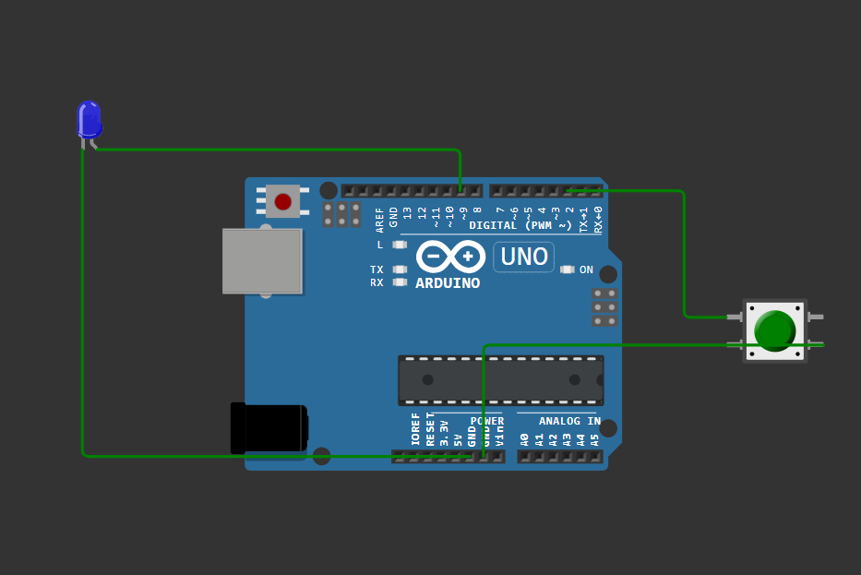

*Button is not pressed, light is off*

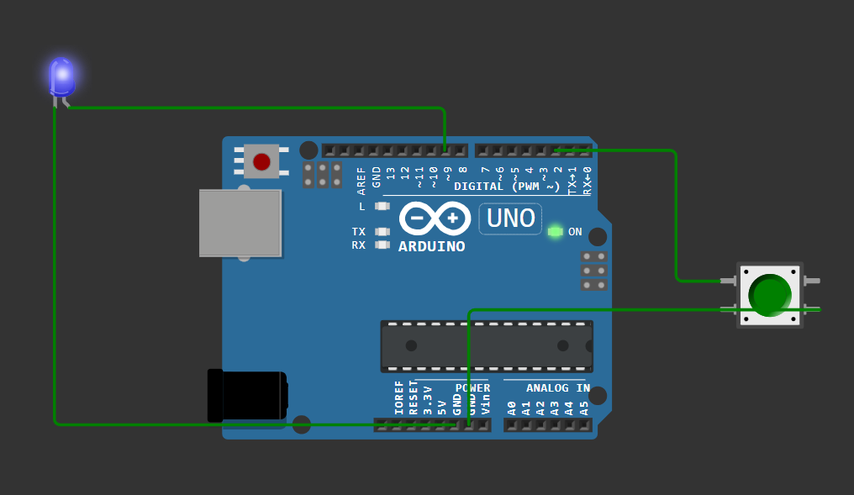

*Button is pressed and hold, light is on*

*Button only needs one push*

const int buttonPin = 2;

const int ledPin = 9;

int buttonState;

int lastButtonState = LOW;

bool ledState = false;

unsigned long lastDebounceTime = 0;

unsigned long debounceDelay = 50;

void setup() {

  pinMode(ledPin, OUTPUT);

  pinMode(buttonPin, INPUT_PULLUP);

}

void loop() {

  int reading = digitalRead(buttonPin);

  if (reading != lastButtonState) {

    lastDebounceTime = millis();

  }

  if ((millis() - lastDebounceTime) > debounceDelay) {

    if (reading == LOW && buttonState == HIGH) {

      ledState = !ledState;

      digitalWrite(ledPin, ledState ? HIGH : LOW);

    }

    buttonState = reading;

  }

  lastButtonState = reading;

}

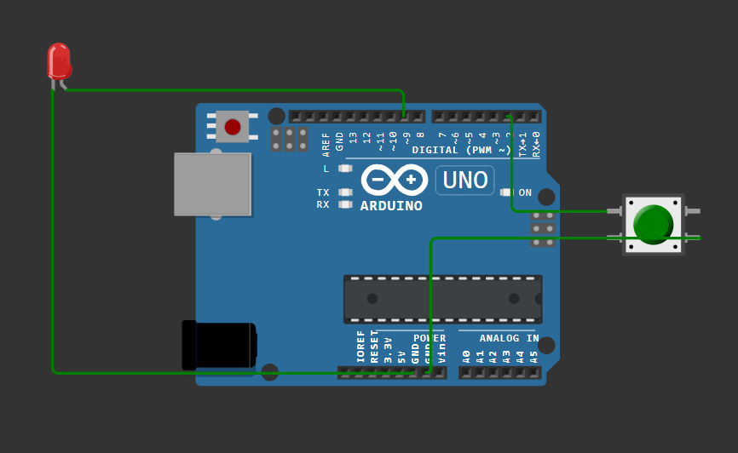

*Light is off before push*

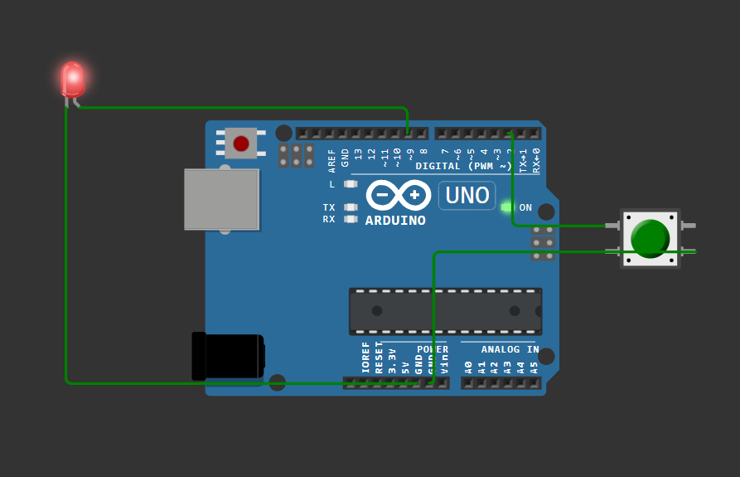

*Light is on after push*

**Button with resistor**

#define BUTTON_PIN 4

void setup()

{

Serial.begin(9600);

pinMode(BUTTON_PIN, INPUT_PULLUP);

}

void loop()

{

byte buttonState = digitalRead(BUTTON_PIN);

if (buttonState == LOW) {

Serial.println("Button is pressed");

}

else {

Serial.println("Button is not pressed");

}

delay(1000);

}

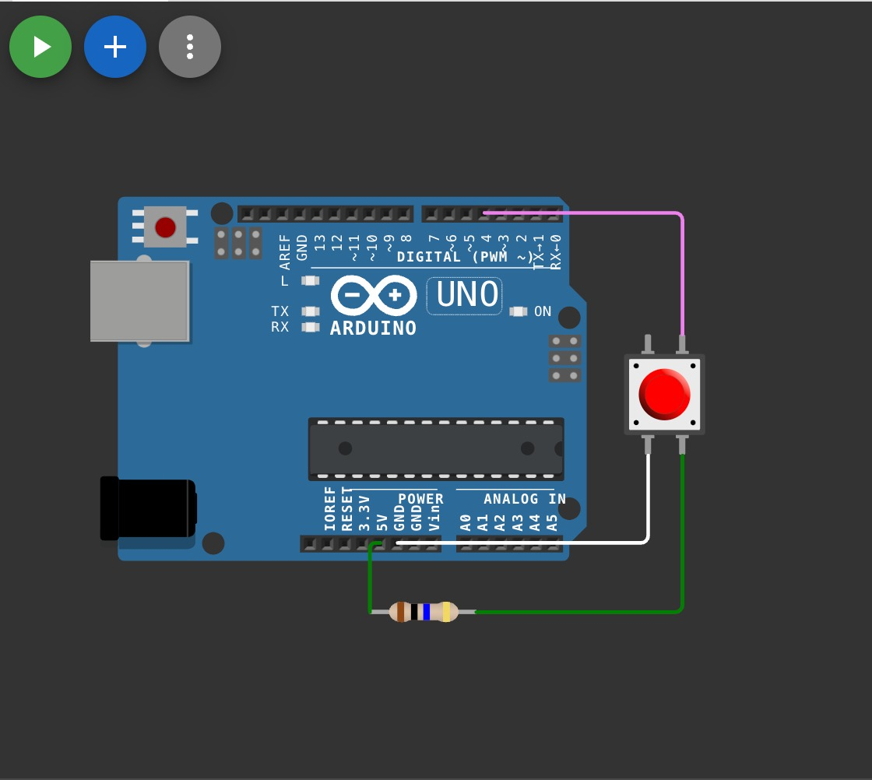

**Button with Resistor**

#define BUTTON_PIN 4

void setup()

{

Serial.begin(9600);

pinMode(BUTTON_PIN, INPUT_PULLUP);

}

void loop()

{

byte buttonState = digitalRead(BUTTON_PIN);

if (buttonState == HIGH) {

Serial.println("Button is pressed");

}

else {

Serial.println("Button is not pressed");

}

delay(1000);

}

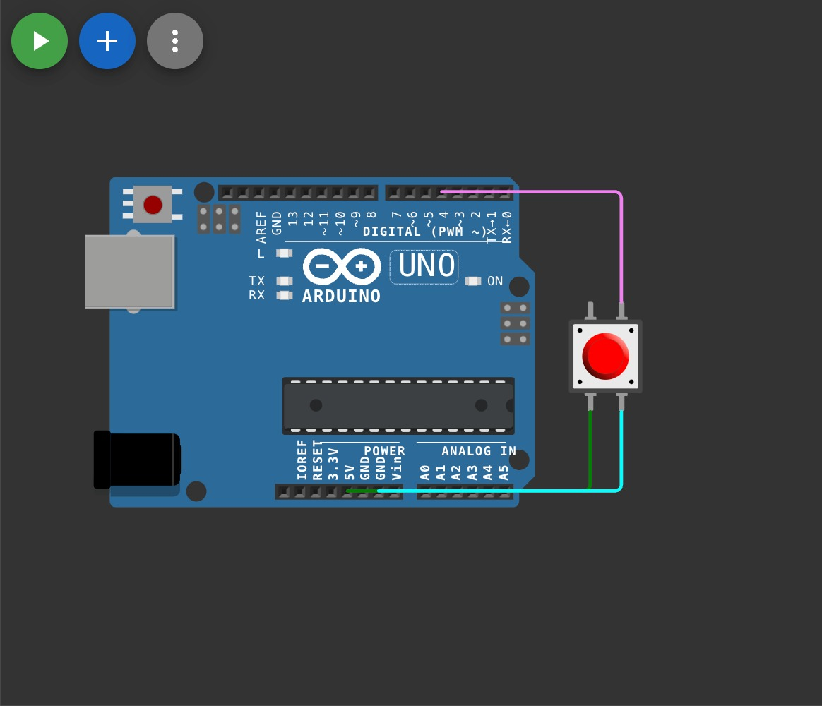

**Bounce Part**

#define BUTTON_PIN 4

byte lastButtonState = LOW;

void setup() {

Serial.begin(9600);

pinMode(BUTTON_PIN, INPUT);

}

void loop() {

byte buttonState = digitalRead(BUTTON_PIN);

if (buttonState != lastButtonState) {

lastButtonState = buttonState;

if (buttonState == LOW) {

Serial.println("Button released");

}

}

}

**Debounce Part**

#define BUTTON_PIN 4

byte lastButtonState = LOW;

unsigned long debounceDuration = 50; // millis

unsigned long lastTimeButtonStateChanged = 0;

void setup() {

Serial.begin(9600);

pinMode(BUTTON_PIN, INPUT);

}

void loop() {

if (millis() - lastTimeButtonStateChanged > debounceDuration) {

byte buttonState = digitalRead(BUTTON_PIN);

if (buttonState != lastButtonState) {

lastTimeButtonStateChanged = millis();

lastButtonState = buttonState;

if (buttonState == LOW) {

Serial.println("Button released");

}

}

}

}

**Some Important Terms :**

**1. Bounce**

* **Definition:** Bounce is a physical effect where a push button or switch creates rapid, unintended on/off signals when pressed or released. This occurs because the metal contacts inside the button don't connect cleanly and may vibrate momentarily, causing multiple signals.
* **Impact:** Without handling bounce, a button press could register multiple presses, leading to erratic behavior in electronic circuits.

**2. Debounce**

* **Definition:** Debounce is the process of eliminating or smoothing out the rapid, unintended signals caused by bouncing in a button or switch. In software, this is typically handled by adding a small delay or by detecting only stable button states.
* **Purpose:** Debouncing ensures that a single, clean signal is registered for each press or release, allowing more accurate button readings.

**3. Pull-Up Resistor**

* **Definition:** A Pull-Up Resistor is a resistor connected between an input pin and the positive supply voltage (e.g., 5V) to keep the pin at a HIGH voltage level when the button or switch is open (not pressed). When the button is pressed, it connects the pin to ground (0V), pulling the input to LOW.
* **Usage:** Pull-up resistors are commonly used with microcontroller input pins to define a known voltage state when a button is not pressed.

**4. Pull-Down Resistor**

* **Definition:** A Pull-Down Resistor is a resistor connected between an input pin and ground (0V) to keep the pin at a LOW voltage level when the button or switch is open. When the button is pressed, it connects the pin to the positive supply voltage, pulling the input to HIGH.
* **Usage:** Pull-down resistors are used to ensure an input pin reads a LOW state when a button is not pressed, providing a stable reference voltage.